SUNDAY, NOVEMBER 8 TONE 6
23rd Sunday after Pentecost (7th of Luke) Synaxis of the Archangel Michael and the other Bodiless Powers
Archangels Gabriel, Raphael, Uriel, Salaphiel, Jegudiel, and Barachiel
"Lord I Call..." – Tone 6
Reader: In the Sixth Tone, Lord, I call upon You, hear me!

Lord, I call upon You, hear me!
Hear me, O Lord!
Lord, I call upon You, hear me!
Receive the voice of my prayer,
when I call upon You!//
Hear me, O Lord!
Let my prayer arise
in Your sight as incense,
and let the lifting up of my hands
be an evening sacrifice!//
Hear me, O Lord!

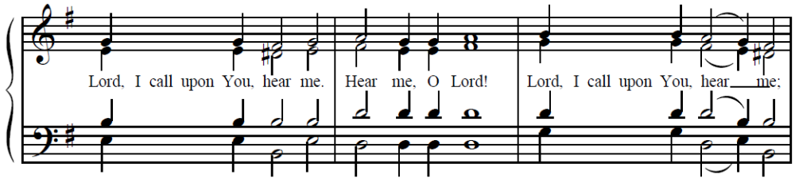
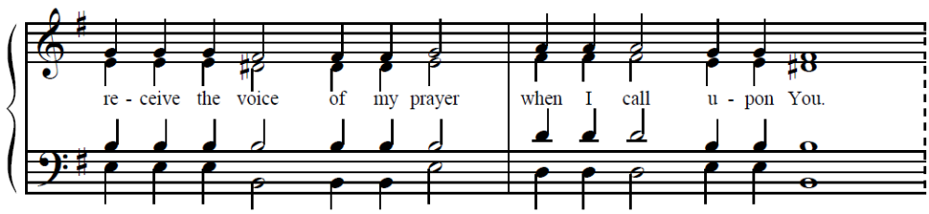
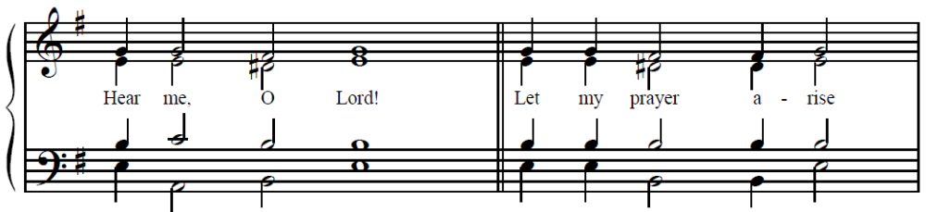
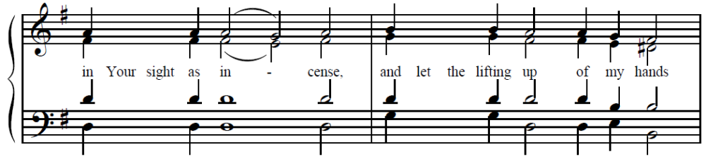
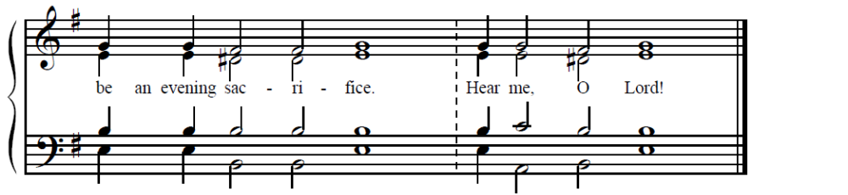
Reader: (Reads text from service book)
v. (10) Bring my soul out of prison, that I may give thanks to Your name!
Possessing victory over Hades, O Christ,
since You are free among the dead,
You ascended the Cross
raising with Yourself those who sat in the shades of death.//
Drawing life from Your light, O Almighty Savior, have mercy on us!
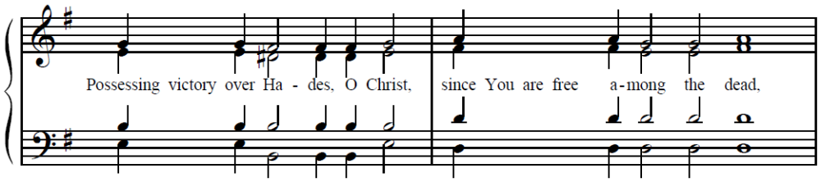
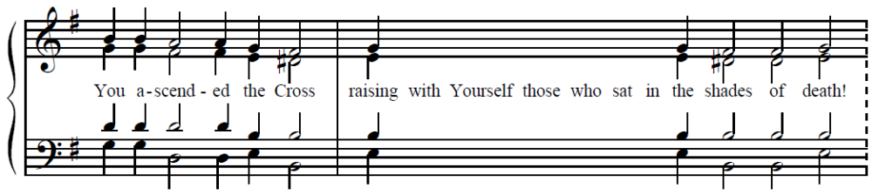
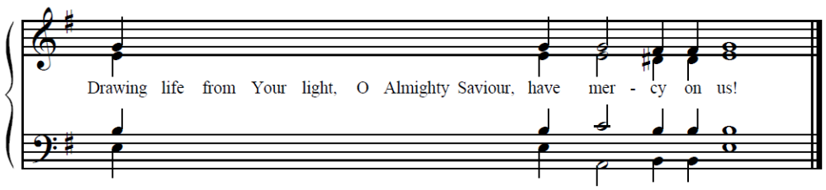
v. (9) The righteous will surround me; for You will deal bountifully with me.
Today Christ tramples on death,
for He is risen as He said!
Let us all sing this song,
for He has granted joy to the world:
“O Light unapproachable, O Fountain of life!//
O Savior Almighty, have mercy on us!”
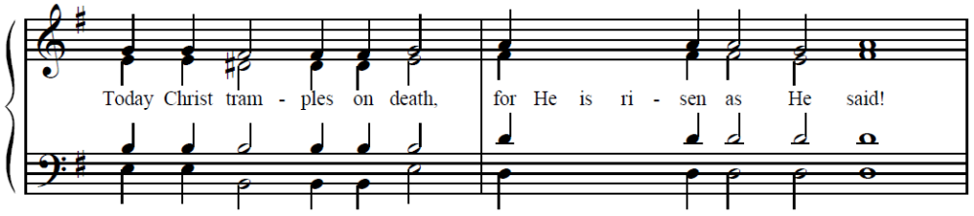
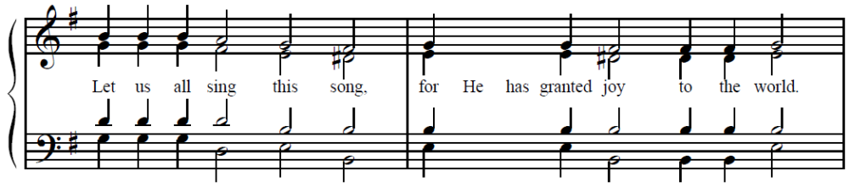
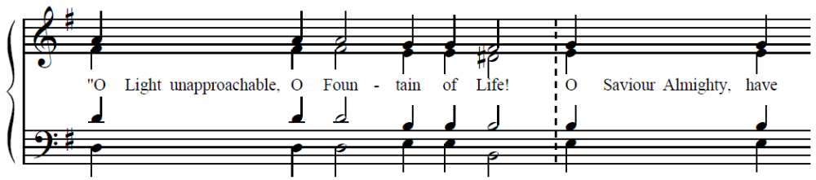

v. (8) Out of the depths I cry to You, O Lord. Lord, hear my voice!
Where shall we sinners flee from You, for You are in all creation?
In heaven You dwell!
In Hades You trampled on death!
In the depths of the sea?
Even there is Your hand, O Master!
To You we flee, and falling before You, we pray://
“O You Who rose from the dead, have mercy on us!”
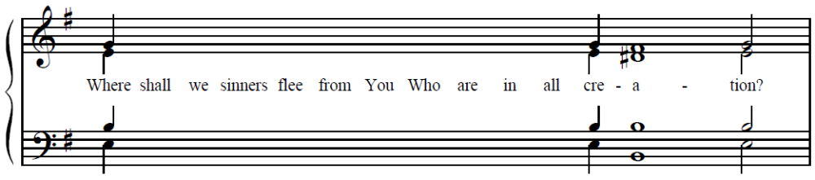
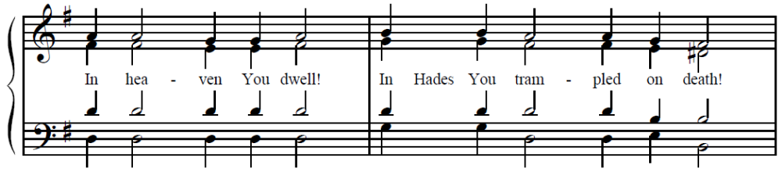
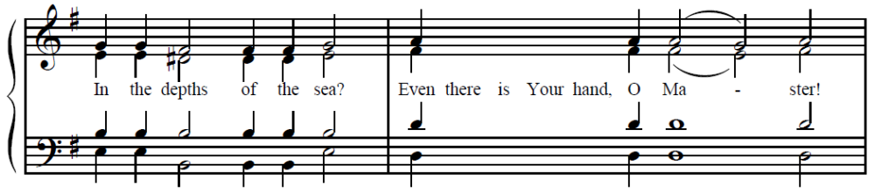
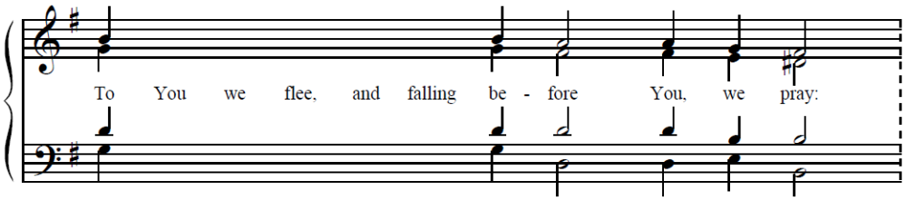
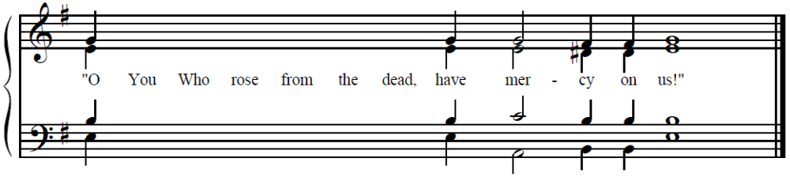
v. (7) Let Your ears be attentive to the voice of my supplications!
In Your Cross, we glory, O Christ.
We sing and glorify Your Resurrection.
For You are our God,//
and we know no other than You.
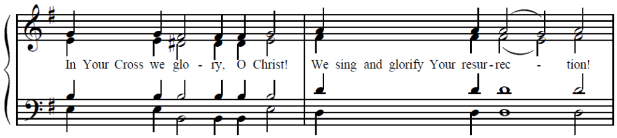
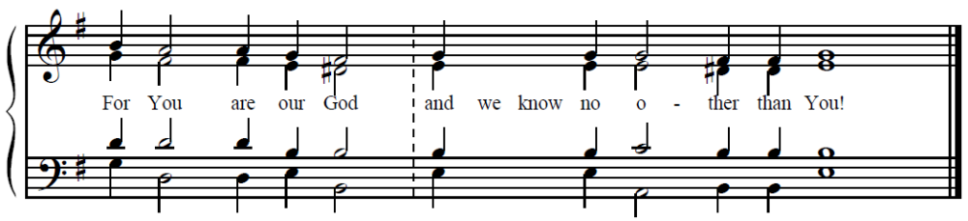
v. (6) In the Fourth Tone, If You, O Lord, should mark iniquities, Lord, who could stand? But there is forgiveness with You.
Tone 4 (for Archangel Michael) (As one valiant among the martyrs)
O Michael, the Chief Captain,
you have been revealed as the brightest attendant of the triply-radiant Godhead.
Together with the heavenly powers you cry out with joy:
“Holy are You, O Father,
Holy are You, O Word, also without beginning,
Holy are You, O Holy Spirit:
one glory, one kingdom, one nature,//
one Godhead and power!”
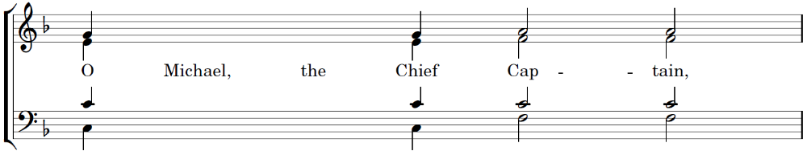
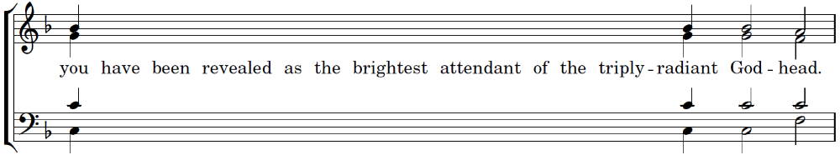
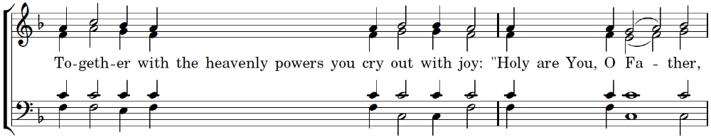
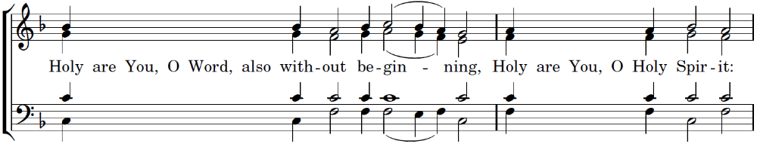
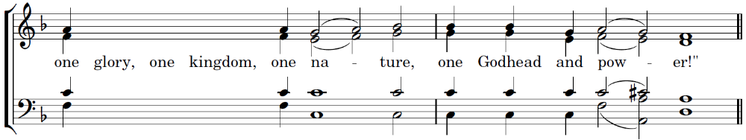
v. (5) For Your Name’s sake I wait for You, O Lord. My soul has waited for Your word; my soul has hoped on the Lord.
O Michael, first of Angels,
fiery is your appearance and miraculous your beauty!
You traverse creation by your immaterial nature,
fulfilling the commands of the Creator of all.
By your might you are known as powerful,//
and you have made your temple, honored by your holy name, a source of healings.
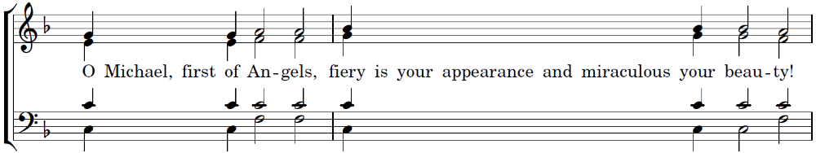
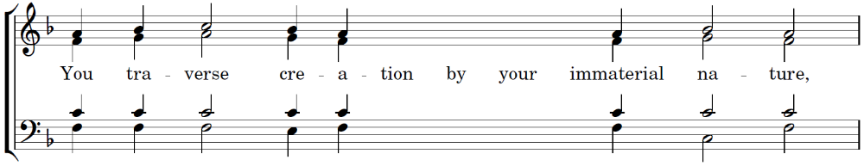
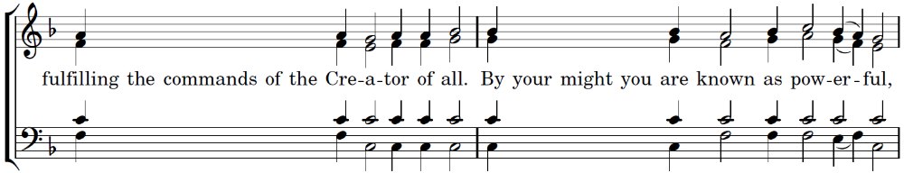
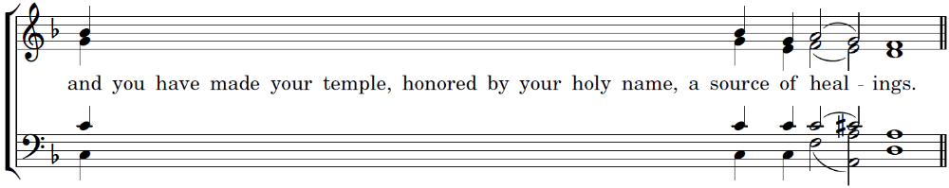
v. (4) From the morning watch until night, from the morning watch, let Israel hope on the Lord!
O Lord, You make Your angels spirits, as it is written,
and Your ministers a flaming fire.
You, O Word, have declared Chief Captain Michael
as first among the ranks of Your archangels:
He submits to Your commands,//
and proclaims with fear the thrice-holy hymn to Your glory.
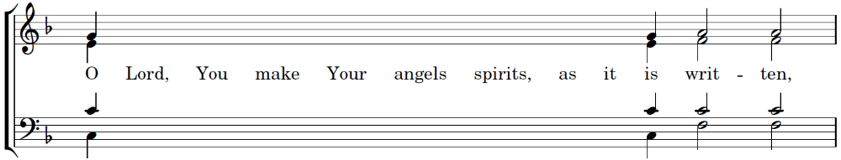
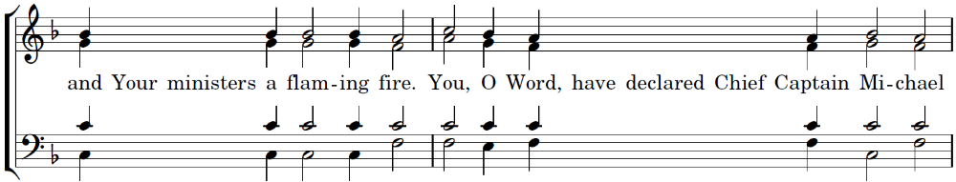
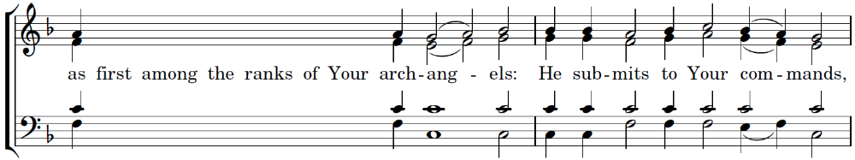
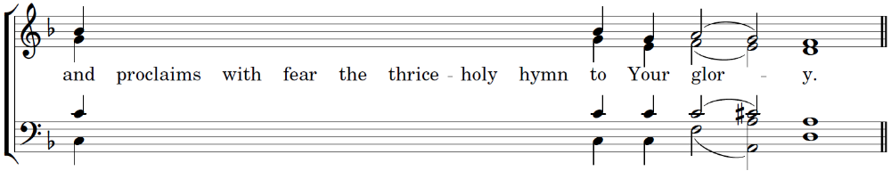
v. (3) In the Same Tone, For with the Lord there is mercy and with Him is plenteous redemption, and He will deliver Israel from all his iniquities.
Tone 4 (for Archangel Gabriel) (You have given a sign)
The Eternal Wisdom established you, O Gabriel,
as a second light reflecting things divine,
illumining the whole creation,
and revealing to us the divine mystery hidden from before the ages:
the bodiless One made flesh in a virgin womb//
and become Man that He might save mankind.
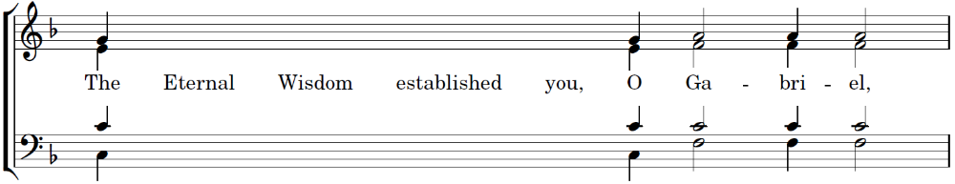
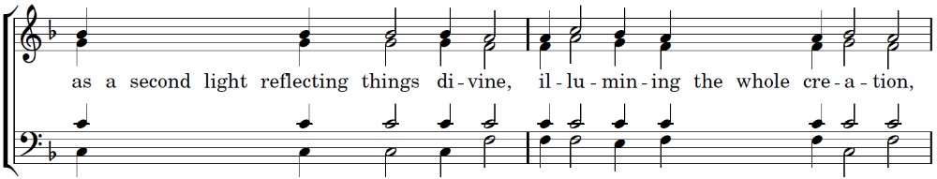
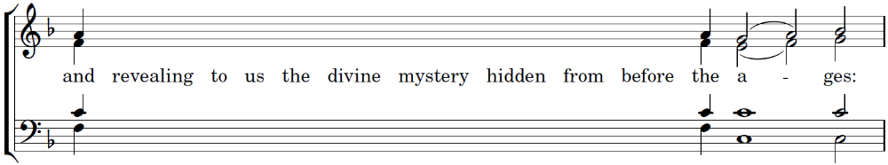
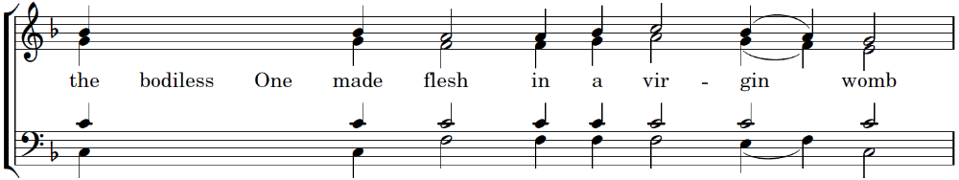
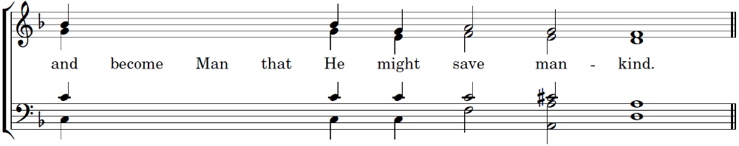
v. (2) Praise the Lord, all nations! Praise Him, all peoples!
Standing before the throne of the three-fold radiance of the Godhead,
brilliant with the splendors that unceasingly pour forth from It,
from the fog of passions free those of us on earth who praise you with joy!
Illumine us, O Chief Captain Gabriel,//
the intercessor for our souls!
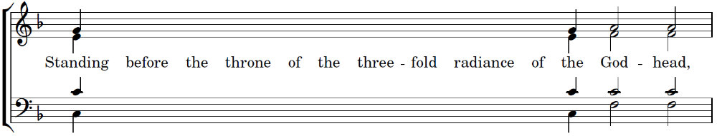
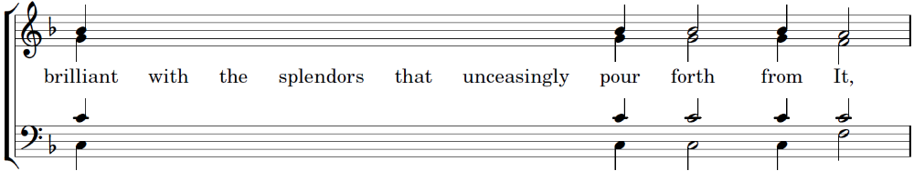
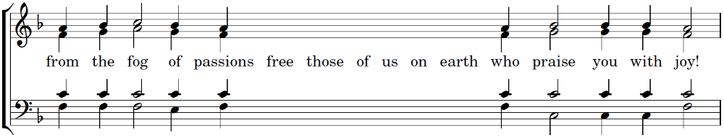
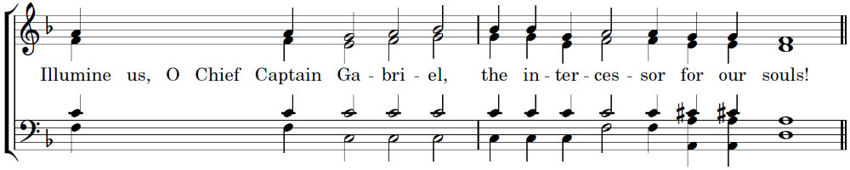
v. (1) For His mercy is confirmed on us, and the truth of the Lord endures forever.
Destroy the wanton violence of Hagar’s sons—
the enemies who unceasingly attack thy flock;
heal the divisions of the Church,
calm the storm of unending temptations;
from danger and calamities deliver us who honor you in love
and who hasten to your protection, O Chief Captain Gabriel,//
the intercessor for our souls!
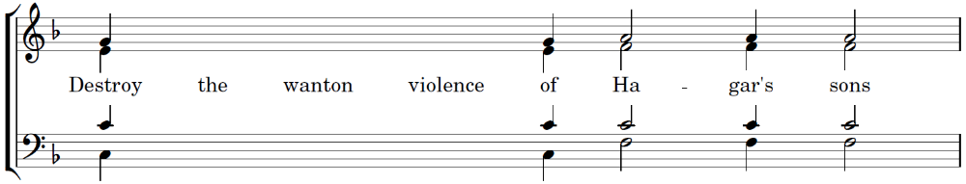
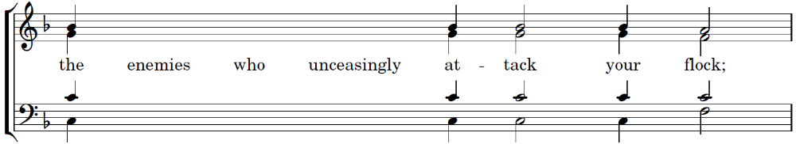
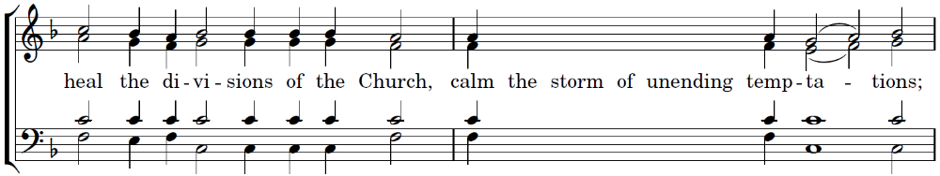
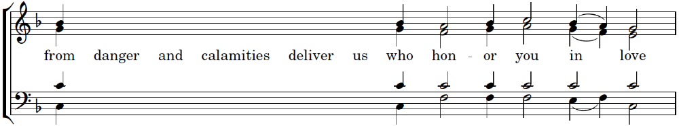
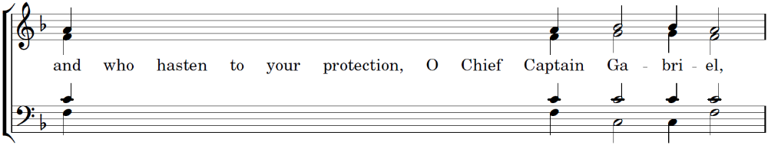
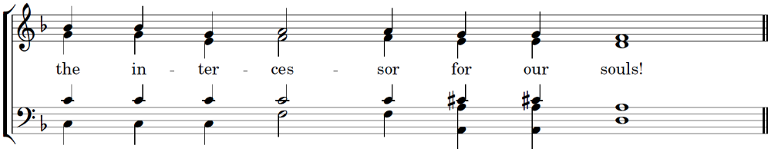
In the Sixth Tone, Glory to the Father, and to the Son, and to the Holy Spirit;
Tone 6 (for Archangel Michael, by Byzantius)
Rejoice with us, O Princes of the angelic Powers,
for your leader and our champion, the great Chief Captain,
gloriously appearing in his honored temple, sanctifies it!
Therefore, rightfully singing praises to him, we cry out:
“Save us under the protection of your wings,//
O Michael, the greatest archangel!”
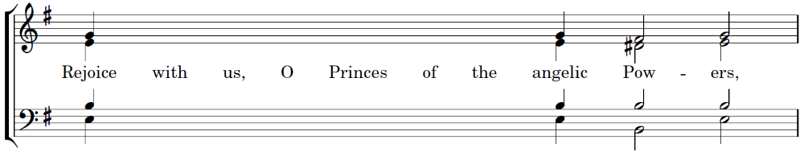
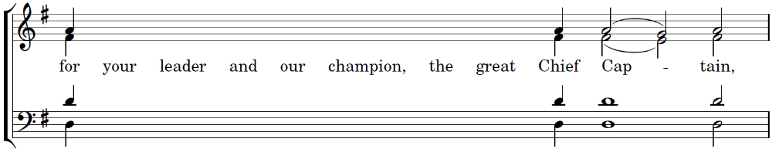
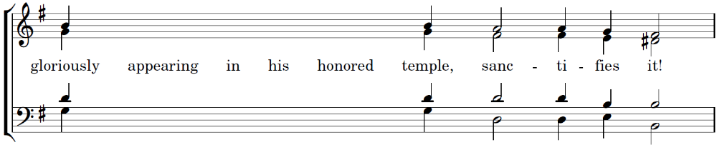
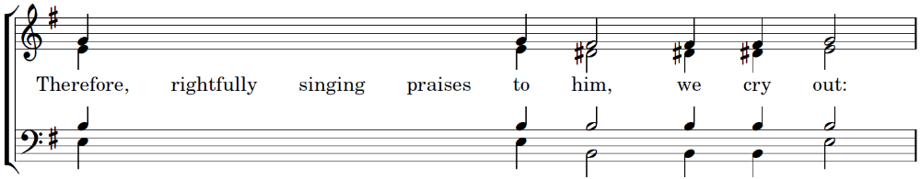
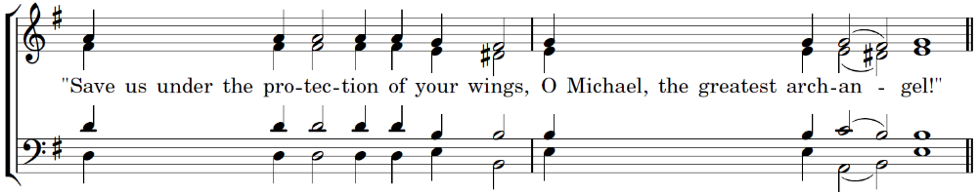
In the Same Tone, now and ever, and unto ages of ages. Amen.
Tone 6 (Theotokion – Dogmatikon)
Who will not bless you, O most holy Virgin?
Who will not sing of your most pure childbearing?
The only-begotten Son shone timelessly from the Father,
but from you He was ineffably incarnate.
God by nature yet Man for our sake,
Not two persons but One known in two natures.
Entreat Him, O pure and all-blessed Lady,//
to have mercy on our souls!
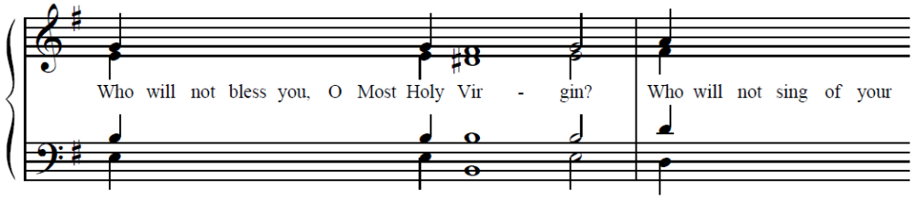
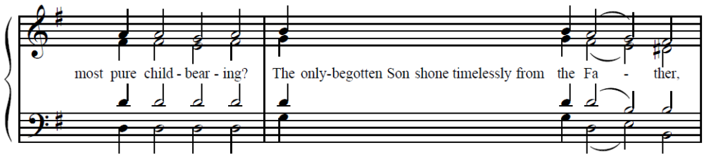
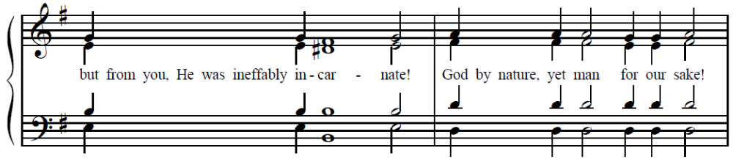
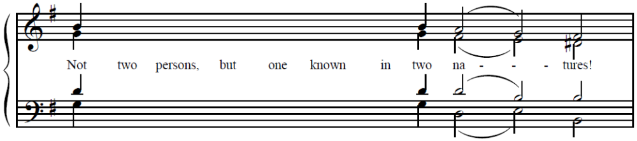
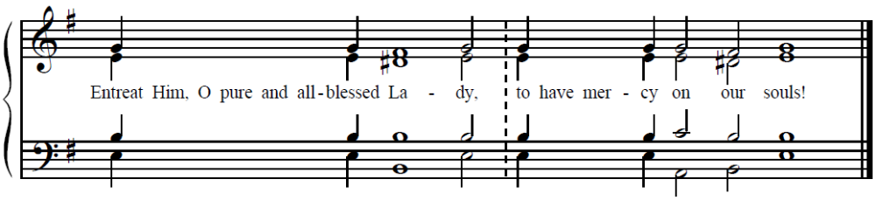
Priest: Wisdom! Let us attend!
People: O Gladsome Light … (p. 16) Prokeimenon of the Day, Three readings

Prokeimenon of the Day, three readings
Priest: Wisdom!
Reader: The reading from Joshua. (Joshua 5:13-15)
Priest: Let us attend!
Reader: And it happened as Joshua was at Jericho and looking up with his eyes, he saw a person standing before him and a drawn sword was in his hand; and approaching, Joshua said to him, "Are you an ally or from the enemy?" He said to him, "I, the commander of the army of the Lord, now am here." And Joshua fell on his face upon the earth and said to him, "Master, what do you command your servant?" And the Lord's commander said to Joshua, "Untie your sandals from your feet. For the place upon which you are now standing is holy:'
Priest: Wisdom!
Reader: The reading from the Judges of Israel. (Judges 6:2, 7, 11-24)
Priest: Let us attend!
Reader: The hand of Midian grew strong against Israel, and the sons of Israel made for themselves holes in the hills, caves, and hanging things away from the face of Midian. So the sons of Israel called to the Lord from the face of the Midianites.
The angel of the Lord came, and he sat under the terebinth, which is in Ophrah, in the land of Joash father of Esdri. His son Gideon was beating out grain in a winepress to escape from the face of Midian. And the angel of the Lord was seen by him and said to him, "The Lord is with you, mighty one of power!' And Gideon said to him, "In me, my Lord! But if the Lord is with us, why have these troubles found us? And where are all his wonders that our fathers fully told us, saying, 'Did not the Lord lead up us out of Egypt? And now he has cast us out, and he has given us into the hand of Midian!' Then the angel of the Lord turned to him and said, "Go in this strength of yours, and you shall save Israel from the hand of the Midianites. Look, I have sent you!' And Gideon said to him, "In me, my Lord, by what shall I save Israel? Look, my thousand is weak in Manasseh, and I am the insignificant one in the house of my father!' So the angel of the Lord said to him, "The Lord shall be with you, and you shall strike the Midianites like one man!' Gideon said to him, "If then I have found mercy In your eye, and you do for me today all that you have said to me, do not depart from here until my coming to you. I will bring forth the sacrifice and put it before your face!' And he said, "I am; I will sit until your return!'
Then Gideon went in and prepared a kid of the goats and an ephah of unleavened flour. He put the meat in the basket, and he placed the broth in the pot; then he carried them out to him under the terebinth, and he came near. Then the angel of God said to him, "Take the meat and the unleavened bread and put them against that rock and pour out the broth nearby!' And he did thus. The angel of the Lord then stretched out the end of the rod that was in his hand and ignited the meat and the unleavned cakes. And fire went up from the rock and consumed the meat and the unleavened bread. So, the angel of the Lord went from his eyes. Then Gideon saw that this was the angel of the Lord, and Gideon said "Ah, ah, my Lord, O Lord! For I saw the angel of the Lord face to face!' And The Lord said to him, "Peace to you, do not fear; you shall not die." Then Gideon built an altar there for the Lord and called it "Peace of the Lord," its name until this day.
Priest: Wisdom!
Reader: The reading from the Prophecy of Isaiah. (Isaiah 14:7-20)
Priest: Let us attend!
Reader: All the land cries out with cheer. And the trees of Lebanon were cheerful at you, and the cedar of Lebanon: 'Since you fell asleep, the one who strikes us has not gone up: Hades below was embittered after meeting you; all the giants who ruled the land, who roused all the kings of the nations from their thrones, rose together with you. All will answer and will say to you, 'Even you were taken, just as we also were, and you were counted among us: Your glory, your abundant cheer, went down into Hades; beneath you they will spread decay, and your covering will be a worm. How the dawn-bringer, who rises early, fell from the heavens; the one who sends to all the nations was crushed into the earth. But you said in your .mind, 'I will go up into the heavens; above the stars of the heavens I will set my throne! I will sit on a high mountain, upon the high mountains toward the north. I will go up above the clouds; I will be like the Most High!' But now you will go down into Hades, and into the foundations of the earth. Those who see you will be astonished at you and say 'Is this the person who provokes the land, shaking kings, making the whole inhabited land desolate? And he brought down its Cities; he did not release those under attack: All the nations' kings fell asleep in honor, each person in his house. But you will be thrown among the mountains like a loathed corpse, along with many dead, stabbed by swords, going down into the netherworld. The way a blood-stained garment will not be clean so neither will be you clean, for you destroyed my land and you killed my people. You will certainly not remain into eternity, evil seed!
Then, the Augmented Litany (p. 18)

Aposticha – Tone 6
Your Resurrection, O Christ our Savior,
the Angels in heaven sing!
Enable us on earth//
to glorify You in purity of heart!
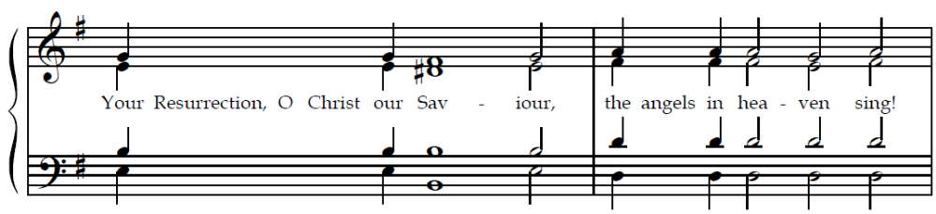
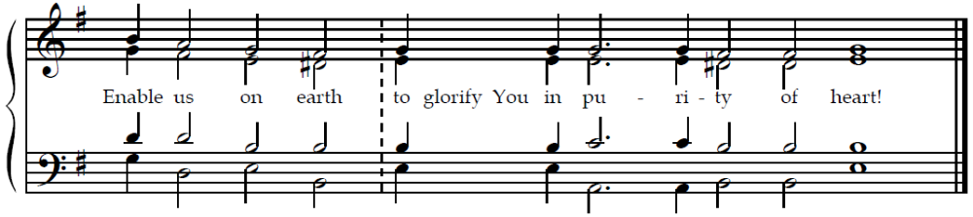
v: The Lord is King; He is robed in majesty!
Destroying the gates of hades,
breaking the chains of death,
You resurrected the fallen human race as almighty God!//
O Lord, Who rose from the dead, glory to You!
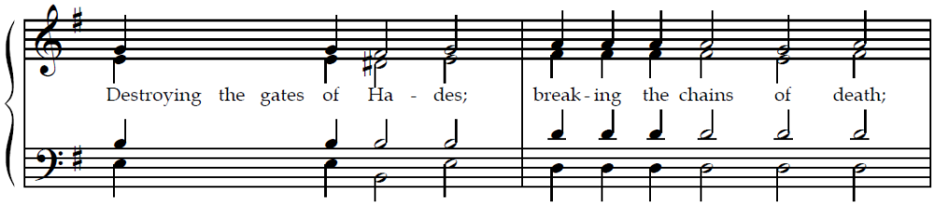
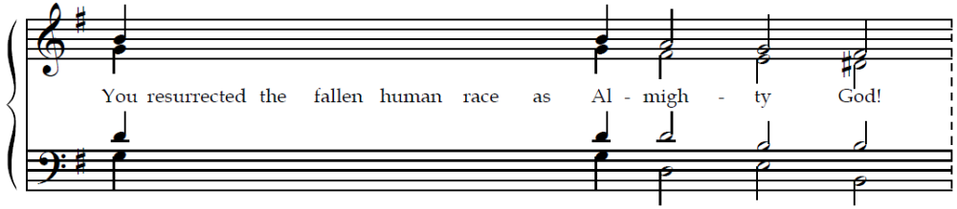
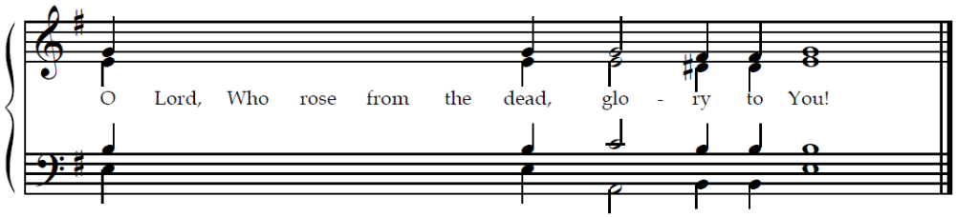
v: For He has established the world, so that it shall never be moved.
Desiring to return us to Paradise,
Christ was nailed to the Cross and placed in a tomb.
The Myrrhbearing Women sought Him with tears, crying,
“Woe to us, O Savior!
How do You deign to descend to death?
What place can hold Your life bearing body?
Come to us as You promised!
Take away our wailing and tears!”
Then the Angel appeared to them:
“Stop your lamentations!
Go, proclaim to the Apostles:
‘The Lord is risen,//
granting us purification and great mercy!’”
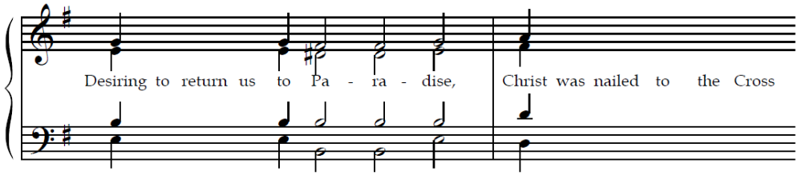
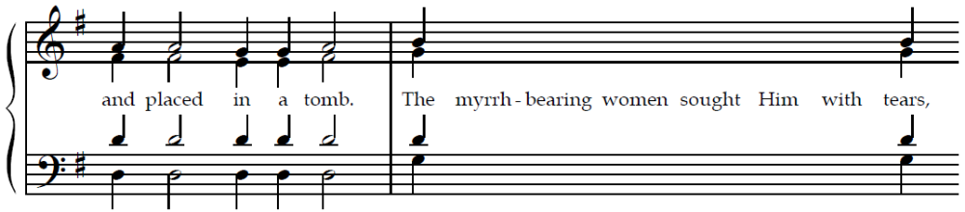
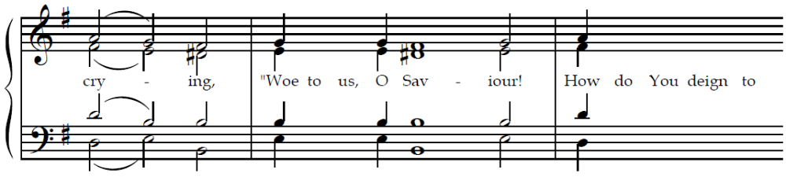
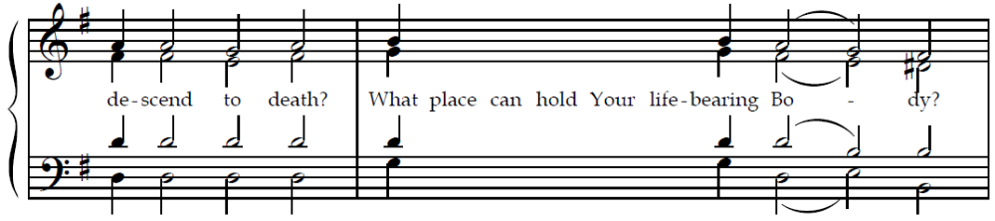
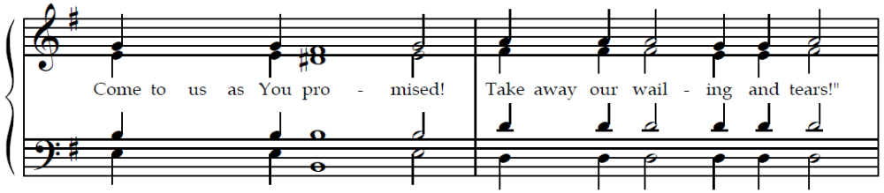
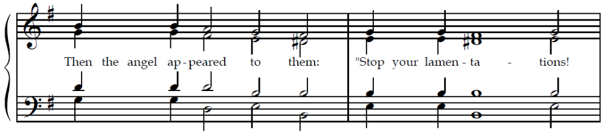
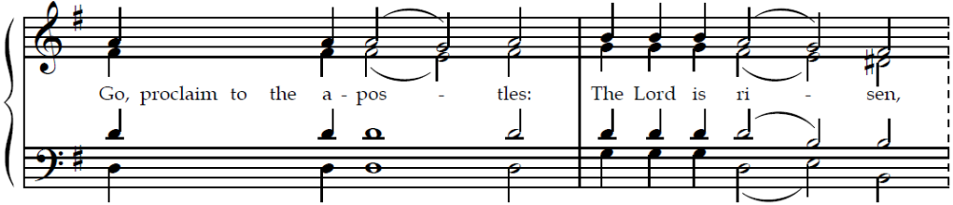

v: Holiness befits Your house, O Lord, forevermore!
Having been crucified as You willed,
by Your burial You captured death, O Christ,
and rose on the third day as God in glory,//
granting the world unending life and great mercy!
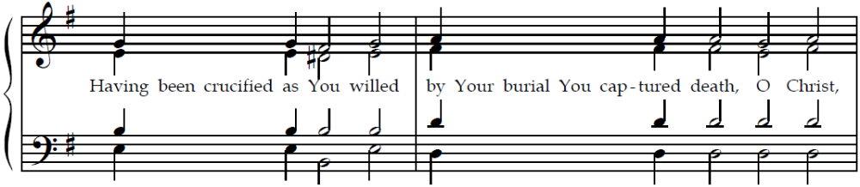
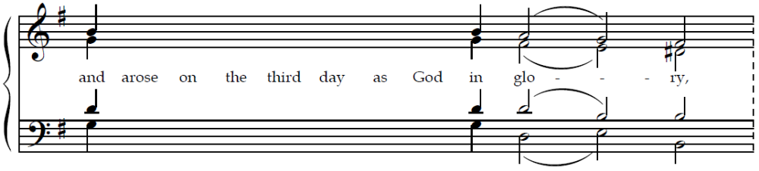
Glory to the Father, and to the Son, and to the Holy Spirit; now and ever, and unto ages of ages. Amen.
Tone 8 (for the Bodiless Powers, by John the Monk)
Since you, O leader of hosts, are first in rank and champion among the Angels,
deliver from every oppression, sorrow, sickness, and sin
those who praise you sincerely and openly implore you!
Since you are immaterial, you clearly behold Him Who is without matter.
You shine with the unapproachable light of the glory of the Lord,
Who in His love for man took flesh for our sakes from a Virgin, //
when He willed to save mankind.
Then, St. Symeon’s Prayer (p. 25)

(at Great Vespers)
Tone 6 Troparion (Resurrection)
(Resurrectional Troparion – Tone 6)
The angelic powers were at Your tomb;
the guards became as dead men.
Mary stood by Your grave,
seeking Your most pure body.
You captured Hades,
not being tempted by it.
You came to the Virgin, granting life.//
O Lord, Who rose from the dead, glory to You.
Glory to the Father, and to the Son, and to the Holy Spirit,
Tone 4 Troparion (Bodiless Powers)
(Troparion for the Bodiless Powers – Tone 4)
O Commanders of the heavenly hosts,
we who are unworthy beseech you:
by your prayers encompass us beneath the wings of your immaterial glory,
and faithfully preserve us who fall down and cry out to you://
“Deliver us from all harm, for you are the Commanders of the Powers on high!”
now and ever, and unto ages of ages. Amen.
Tone 4 Resurrectional Dismissal Theotokion
(Resurrection Dismissal Theotokion – Tone 4)
The mystery of all eternity,
unknown even by Angels,
through you, Theotokos, is revealed to those on earth:
God incarnate by union without confusion.
He voluntarily accepted the Cross for us,
by which He resurrected the first-created man,//
saving our souls from death.
Then, the dismissal (p. 26)

(at the Divine Liturgy)
Tone 6 Troparion (Resurrection)
(Resurrectional Troparion – Tone 6)
The angelic powers were at Your tomb;
the guards became as dead men.
Mary stood by Your grave,
seeking Your most pure body.
You captured Hades,
not being tempted by it.
You came to the Virgin, granting life.//
O Lord, Who rose from the dead, glory to You.
Tone 4 Troparion (Bodiless Powers)
(Troparion for the Bodiless Powers – Tone 4)
O Commanders of the heavenly hosts,
we who are unworthy beseech you:
by your prayers encompass us beneath the wings of your immaterial glory,
and faithfully preserve us who fall down and cry out to you://
“Deliver us from all harm, for you are the Commanders of the Powers on high!”
Glory to the Father, and to the Son, and to the Holy Spirit,
Tone 2 Kontakion (Bodiless Powers)
(Kontakion for the Bodiless Powers – Tone 2)
Commanders of God’s armies
and ministers of the divine glory,
princes of the bodiless angels
and guides of mankind;
ask for what is good for us, and for great mercy,//
O Supreme Commanders of the Bodiless Hosts.
now and ever, and unto ages of ages. Amen.
Tone 6 Kontakion (Resurrection)
(Resurrectional Kontakion – Tone 6)
When Christ God the Giver of Life,
raised all of the dead from the valleys of misery with His mighty hand,
He bestowed resurrection on the human race.//
He is the Savior of all, the Resurrection, the Life, and the God of all.
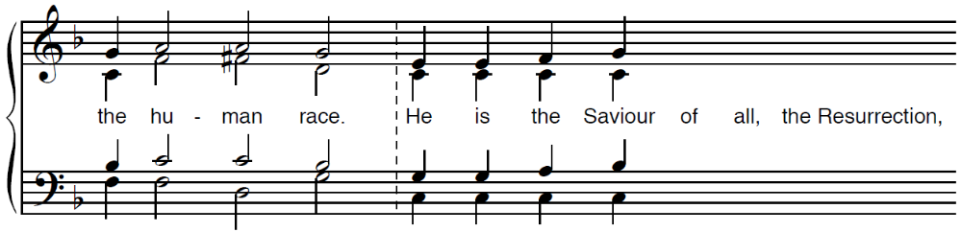
(then, p. 83)

Tone 6 Prokeimenon (Resurrection)
Prokeimenon, Tone 6
Deacon: Let us attend! Priest: † Peace to all!
2nd Deacon/Reader: And with your spirit!
Deacon: Wisdom!
2nd Deacon/Reader: The Prokeimenon, in the 6th Tone: O Lord, save Your people, and bless Your inheritance!
People: O Lord, save Your people, and bless Your inheritance, your inheritance!
2nd Deacon/Reader: To You, O Lord, will I call. O my God, be not silent to me!
People: O Lord, save Your people, and bless Your inheritance, your inheritance!
Tone 4 Prokeimenon (Bodiless Powers)
2nd Deacon/Reader: In the Fourth Tone, He makes His Angels spirits, / and His ministers a flame of fire.
Choir: He makes His Angels spirits, / and His ministers a flame of fire.
Deacon: Wisdom!
Epistle: (220) Ephesians 2:4-10 and (305) Hebrews 2:2-10 (Bodiless Powers)
2nd Deacon/Reader: The Reading from the Epistle of the Holy Apostle Paul to the Ephesians.
Deacon: Let us attend!
2nd Deacon/Reader: Brothers and sisters, God who is rich in mercy, on account of his great love by which he loved us, even when we were dead through our trespasses, made us alive together with Christ. By grace you have been saved! God raised us up with him, and granted us to sit with him in the heavenly places in Christ Jesus, so that in the ages to come, he might show the overflowing treasure of his grace in kindness toward us, in Christ Jesus.
Yes, by grace you have been saved through faith, and not by yourselves. It is the gift of God, not of works, so that no one would boast. For we are his workmanship, created in Christ Jesus for good works, which God prepared in advance so that we should walk in them.
Brothers and sisters, if the word spoken through angels proved reliable and every transgression and disobedience received a just penalty, how will we escape if we neglect so great a salvation! It was first announced by the Lord himself, and it is confirmed to us by those who heard him.
God also bore witness with them, both by signs and wonders, by various works of power and by gifts of the Holy Spirit, according to his own will. Indeed, God did not subject the world to come (which we proclaim) to angels, but there is a place in Scripture where someone has testified:
What is man that you should be concerned for him? Or the son of man, that you care for him?
You made him a little lower than the angels. You crowned him with glory and honor.
You have put all things in subjection under his feet.
Since God has subjected all things to him, he has left nothing that is not subject to him! But now, we do not see all things subjected to him, at least not yet. However, we see him who has been made a little lower than the angels, that is Jesus, crowned with glory and honor because of the suffering of death, so that by the grace of God he should taste death for everyone.
Indeed, it was fitting for God, (for whom are all things and through whom are all things), in bringing many children to glory, to make the author of their salvation perfect through sufferings.
Priest: † Peace to you who read!
Alleluia: Tone 6
2nd Deacon/Reader: And to Your spirit. In the 6th Tone: Alleluia! He who dwells in the shelter of the Most High will abide in the shadow of the heavenly God.
People: Alleluia! Alleluia! Alleluia!
2nd Deacon/Reader: He will say to the Lord: “My Protector and my Refuge; my God, in Whom I trust.
People: Alleluia! Alleluia! Alleluia!
2nd Deacon/Reader: In the Same Tone, Praise Him, all His Angels, praise Him, all His hosts!
Choir: Alleluia! Alleluia! Alleluia!
Gospel: (39) Luke 8:41-56 and (51) Luke 10:16-21 (Bodiless Powers) Pages 136 and 299
Deacon: The reading from the Holy Gospel according to St. Luke.
People: Glory to You O Lord, Glory to You.
Deacon: At that time, a man named Jairus came, and he was a ruler of the synagogue. He fell down at Jesus’ feet and begged him to come to his house because he had an only daughter, about twelve years old, who was dying. But as Jesus went, the crowd pressed against him.
There was a woman who had a flow of blood for twelve years and who had spent all she had on physicians, but she could not be healed by any. She came behind him and touched the fringe of his cloak. Immediately, the flow of her blood stopped. Jesus said, “Who touched me?” As everyone was denying it, Peter and those with him said, “Master, the people are crowding and pressing against you, and you ask, ‘Who touched me?’”
But Jesus said, “Someone has touched me, for I perceived that power has gone out from me.” When the woman saw that she was not hidden, she came forth trembling. Falling down before Jesus, in the presence of all the people, she confessed to him why she had touched him, and how she had immediately been healed. He said to her, “Daughter, be of good cheer! Your faith has made you well. Go in peace.”
While Jesus was still speaking, someone came from the ruler of the synagogue’s house, saying to him, “Your daughter is dead. Do not trouble the Teacher.” But when Jesus heard it, he answered him, “Do not be afraid! Only believe, and she will be healed.”
When Jesus arrived at the house, he did not allow anyone to enter in, except Peter, John, and James, as well as the father of the child and her mother. All were weeping and mourning the girl, but Jesus said, “Do not weep! She is not dead, but sleeping.” But they mocked him, knowing that she was dead. Jesus put them all outside, and taking the girl by the hand, he called, “Child, arise!” Her spirit returned, and she immediately got up. He ordered that something to eat should be given to her. Her parents were amazed, but he commanded them to tell no one what had been done.
The Lord said to his disciples: Whoever listens to you listens to me, and whoever rejects you rejects me. Whoever rejects me rejects the one who sent me.”
The seventy returned with joy, saying, “Lord, even the demons are subject to us in your Name!”
Jesus said to them, “I saw Satan having fallen like lightning from heaven! Behold, I give you authority to tread on serpents and scorpions, and over all the power of the enemy. Nothing will in any way hurt you. Nevertheless, do not rejoice in this, that the spirits are subject to you; but rejoice that your names are written in heaven.”
People: Glory to You O Lord, Glory to You.
Sermon (then p. 89)

Communion Hymn
Praise the Lord from the heavens, praise Him in the highest! He makes His Angels spirits, and His ministers a flame of fire. Alleluia, Alleluia, Alleluia!
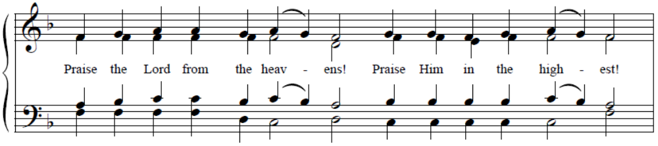
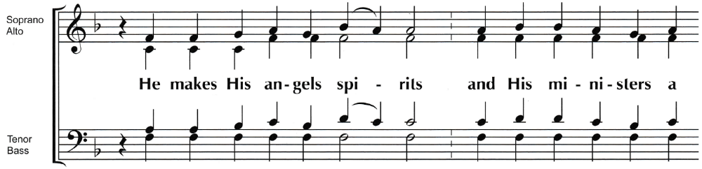
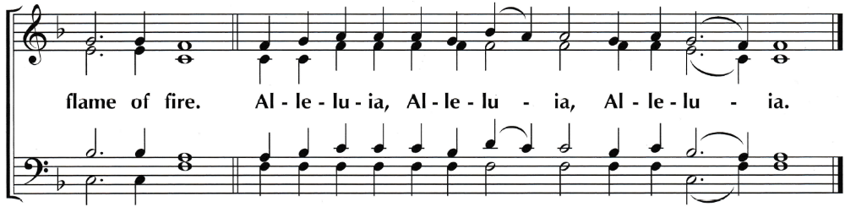
- The Lord has established His throne in the heavens, and His Kingdom rules over all!
- Bless the Lord, O you His angels, you mighty ones who do His word, hearkening to the voice of His word!
- Bless the Lord, all His hosts, His ministers that do His will!
- Bless the Lord, all His works, in all places of His dominion. Bless the Lord, O my soul!

